DeliveryofSprint– 3

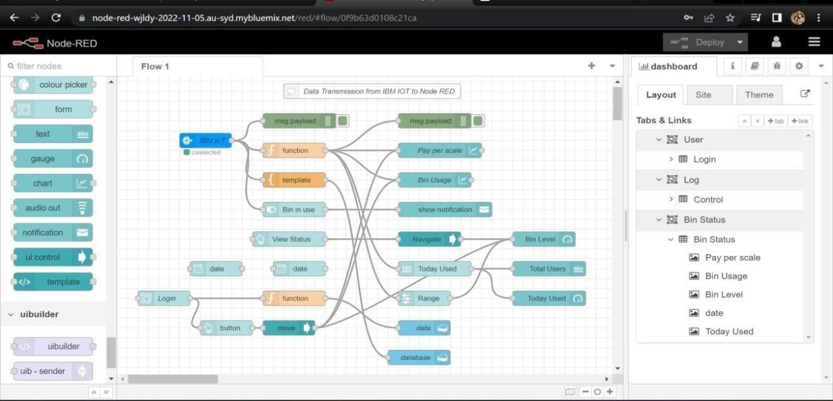

**NodeRedConnectiontoIBMCloudant**

|  |  |
| --- | --- |
| Date | 22November 2022 |
| TeamID | PNT2022TMID06240 |
| ProjectName | Smart Waste Management for Metropolitan Cities -IOT |

1. 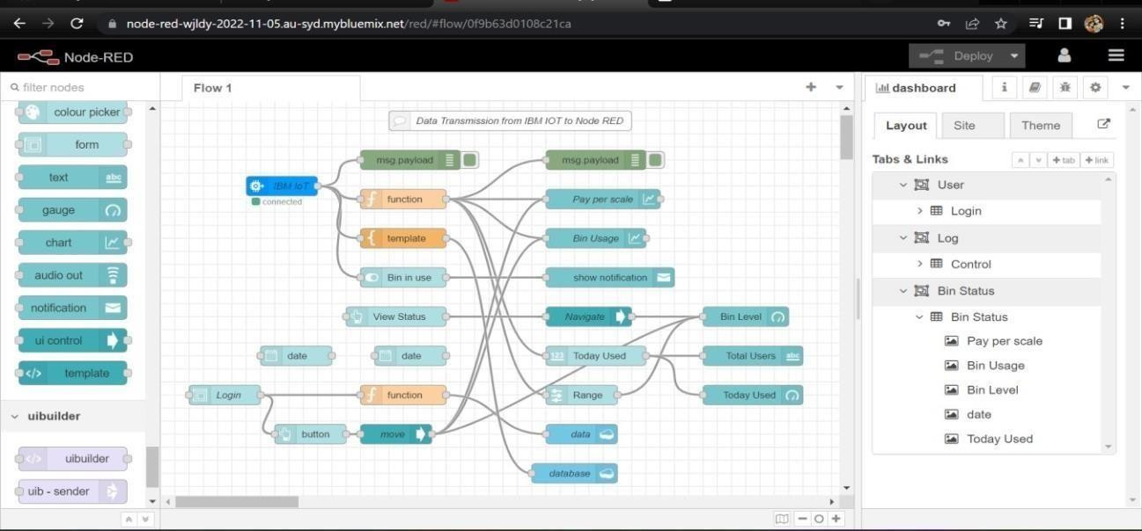Node-REDConnectionsetupfordatatransmissionfromIBMWatsonIOTplatformto

Node-REDdashboard.

1. SimulateWokwiconnectiontotransmitdatafromwokwi accounttoIBMWatsonIOTplatformandthentoNode Reddashboard.

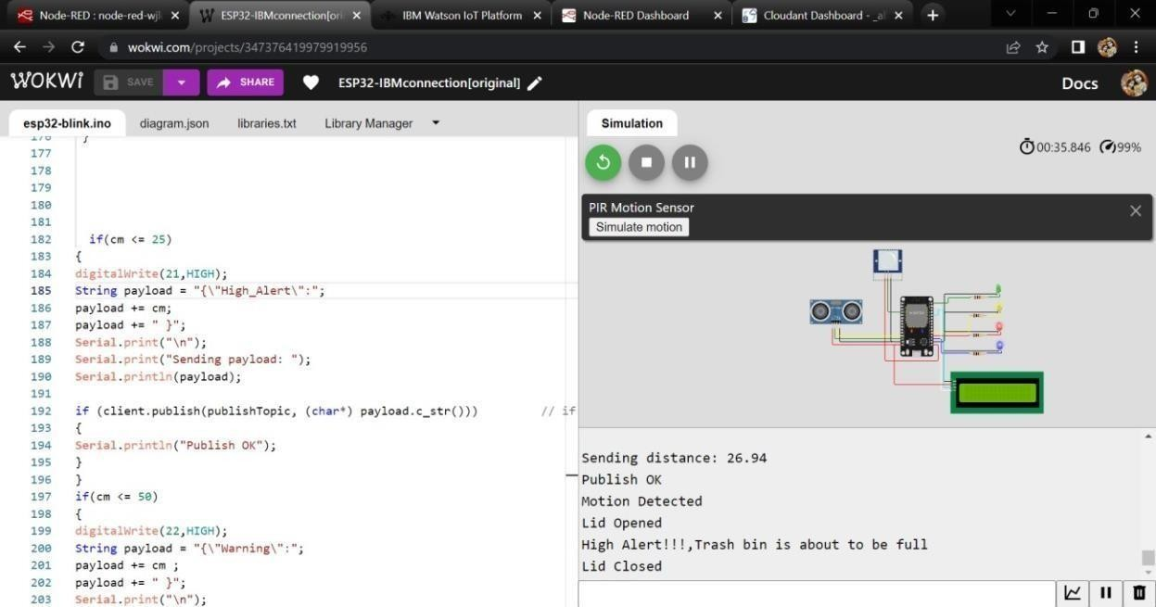

1. Datatransfer toWatsonIOTplatform.

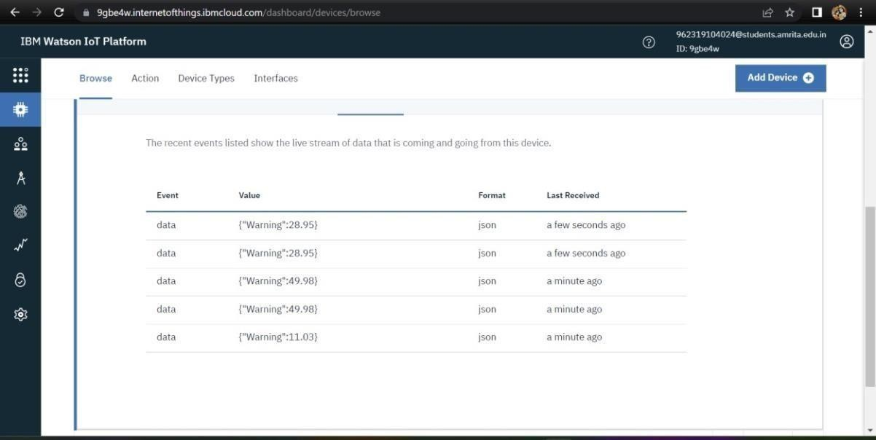

1. Datatransfer fromIBMWatsonIOTplatformand wokwi toNodered.

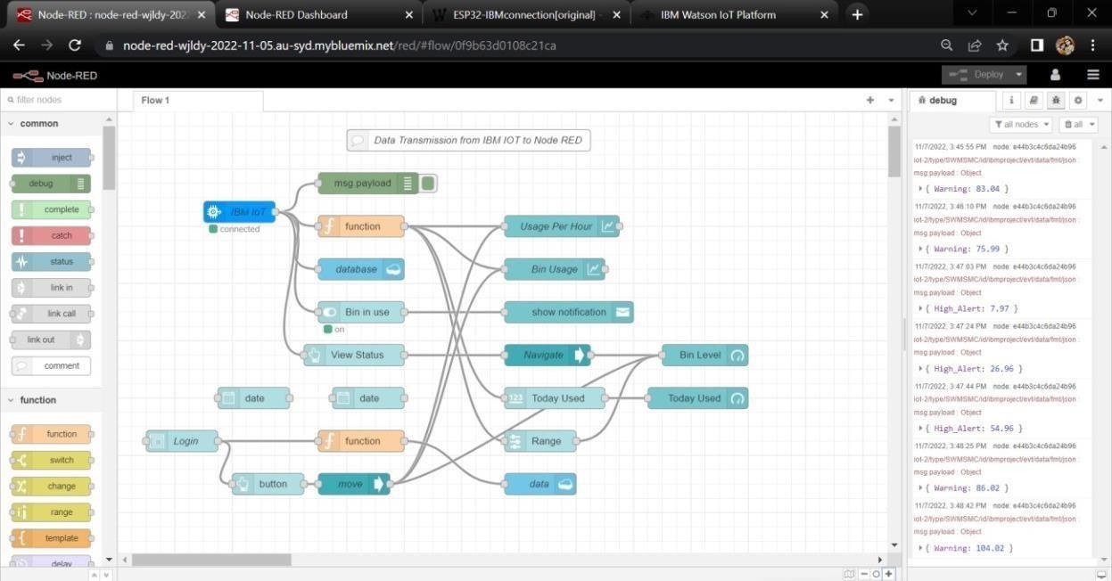

1. StoringdatabaseinIBMcloudantDB.

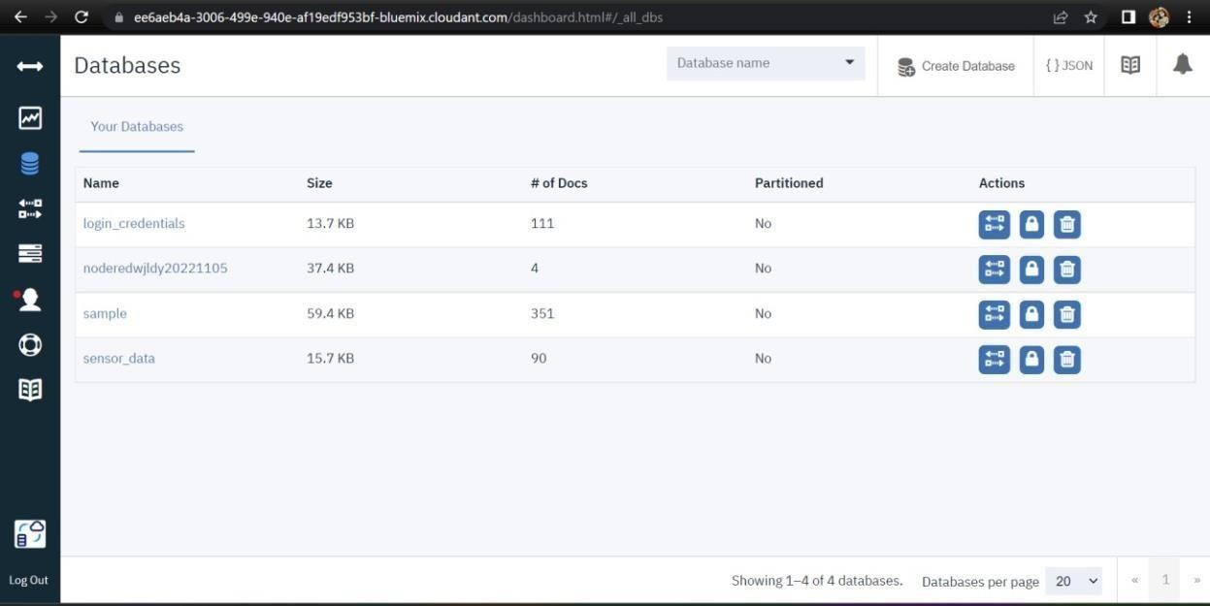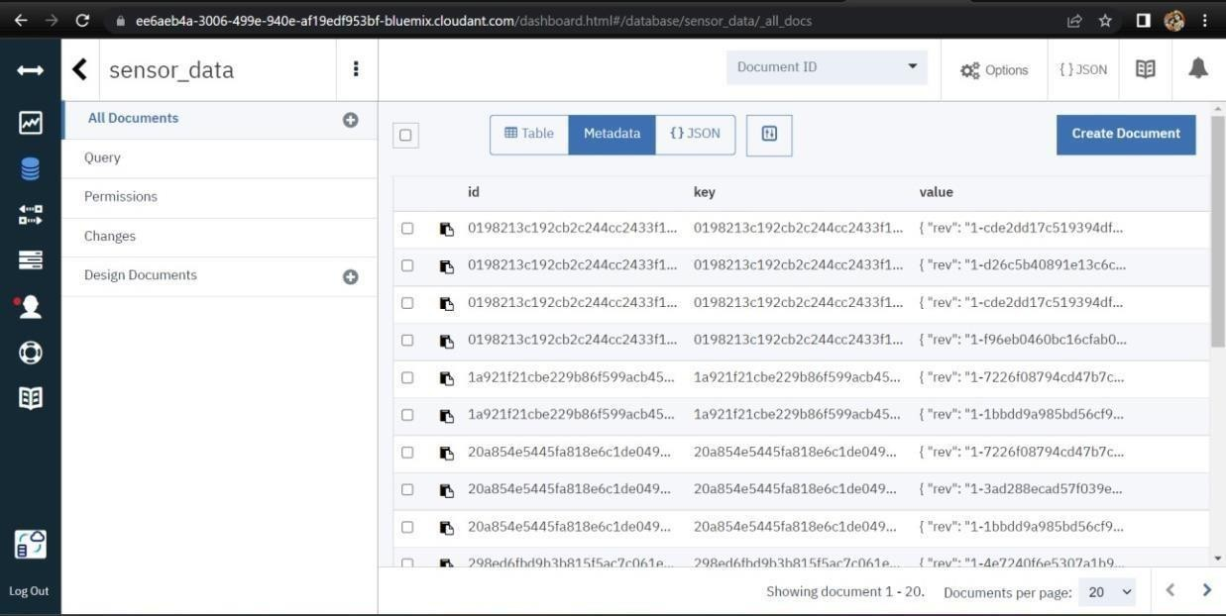

1. Dataisstored inJSONformat

